Project Design Phase-II
Data Flow Diagram & User Stories

Date | 20 February 2026
Team ID | LTVIP2026TMIDS24292
Project Name | LearnHub : Your Center For Skill Enhancement
Maximum Marks | 4 Marks

Data Flow Diagrams:
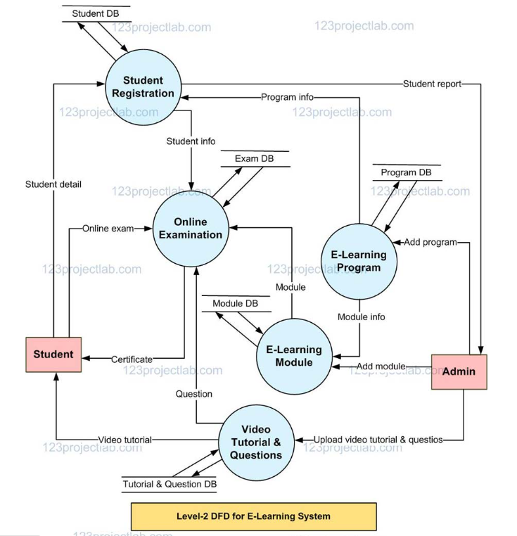

User Stories
User Type | Functional Requirement (Epic) | User Story No | User Story / Task | Acceptance Criteria | Priority | Release
Customer (Web User) | Registration | USN-1 | As a user, I can register using email and password | User account is created successfully | High | Sprint-1
Customer (Web User) | Registration | USN-2 | As a user, I receive a confirmation email after registration | Email verification link is received | High | Sprint-1
Customer (Web User) | Login | USN-3 | As a user, I can log in using valid credentials | User dashboard is accessible | High | Sprint-1
Customer (Web User) | Course Browsing | USN-4 | As a user, I can browse available courses | Course list is displayed | High | Sprint-1
Customer (Web User) | Course Enrollment | USN-5 | As a user, I can enroll in selected courses | Enrollment is successful | High | Sprint-1
Customer (Web User) | Learning | USN-6 | As a user, I can access course videos and materials | Content loads correctly | High | Sprint-1
Customer (Web User) | Assessment | USN-7 | As a user, I can take quizzes after lessons | Quiz results are displayed | Medium | Sprint-2
Customer (Web User) | Progress Tracking | USN-8 | As a user, I can track my learning progress | Progress dashboard updates | Medium | Sprint-2
Administrator | Course Management | USN-9 | As an admin, I can add/update/delete courses | Course changes are saved | High | Sprint-1
Administrator | User Management | USN-10 | As an admin, I can view and manage users | User data is accessible | Medium | Sprint-2
Administrator | Reports | USN-11 | As an admin, I can view analytics and | Reports are generated | Low | Sprint-

